NON-COGNITIVE MEASURES

Table of Contents
1 Demographic Questionnaire (1.5 mins) 2
2 Implicit Theories Of Personality (30 seconds) 3
3 Implicit Theories Of Intelligence 30 seconds 3
4 Need For Cognition (2 mins) 4
5 Goal Orientation (2 mins) 4
6 Memory And Reasoning Self Concept (2 mins) 5
7 Big Five Personality (5 mins) 5
8 Self-efficacy scale (90 seconds) 6
9 General Self-efficacy scale (1 min) 7
10 Cognitive Failures Questionnaire (2.5 mins) 7
11 Cognitive Reflection (3 mins) 8
12 Emotional Intelligence (40 mins) 8

Demographic Questionnaire (1.5 mins)

Instructions
The following information helps us to understand how individual differences in experiences and background influences learning.
- Year of Birth
  - _______
- Gender
  - Male
  - Female
  - Non-binary/Gender diverse
  - Prefer not to say
- Which country do you currently reside in?
- Is English your first language
  - Yes
  - No
    - What language do you speak at home:
      - _____________
    - How long have you been speaking English
      - < 1 year
      - 2-5 years
      - 5-10 years
      - + 10 years
    - How confident are you with your English skills
      - 0 = need assistance when out
      - 100 = proficient and confident
- Your highest level of schooling
  - Primary school
  - Secondary
  - Certificate/Diploma
  - Bachelors degree
  - Masters degree
  - PhD
- Parent 1 - highest level of schooling
  - Primary school
  - Secondary
  - Certificate/Diploma
  - Bachelors degree
  - Masters degree
  - PhD
- Parent 2 - highest level of schooling
  - Primary school
  - Secondary
  - Certificate/Diploma
  - Bachelors degree
  - Masters degree
  - PhD
- Employment
  - Retired (1)
  - Not in paid employment (2)
  - Casual (3)
  - Part-time (4)
  - Full-time (5)
- What is your usual yearly HOUSEHOLD income before tax, from all sources? (please include benefits, pensions, superannuation, etc.)
  - <30K
  - 30-60K
  - 60-90K
  - 90-120K
  - > 120K
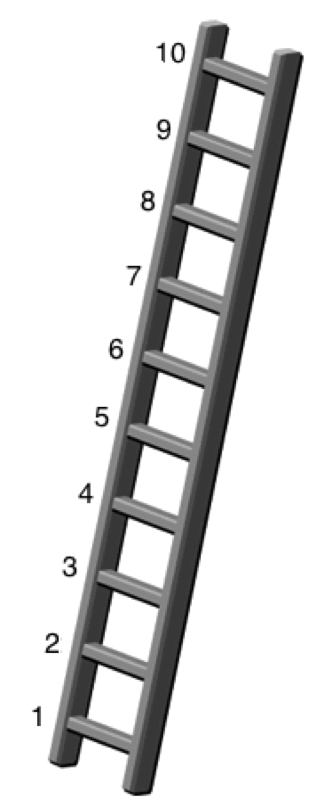
- Think of this ladder as representing where people stand in society. At the top of the ladder are the people who are best off – those who have the most money, most education and the best jobs. At the bottom are the people who are worst off – who have the least money, least education and the worst jobs or no job. The higher up you are on this ladder, the closer you are to people at the very top and the lower you are, the closer you are to the bottom. Where would you put yourself on the ladder?
Please select the number of the rung where you think you stand.
Response options: 1, 2, 3, 4, 5, 6, 7, 8, 9, 10

- Geographic location where you live
  - Urban
  - Suburban
  - Rural
- Rate how often you use the following resources to access information
  - Local library (0=never to 100 = daily)
  - University library (0=never to 100 = daily)
  - Newspapers (0=never to 100 = daily)
  - Internet (online) (0=never to 100 = daily)
  - Friends and family (0=never to 100 = daily)

Implicit Theories Of Personality (30 seconds)
Scale
1-100 slider: Strongly Agree to Strongly disagree

Instructions
The following statements deal with your ideas about personality. There are no right or wrong answers. We are interested in your ideas. Read each statement. Using the scale below each statement, please indicate the extent to which you agree or disagree with each statement.

Items
- The kind of person you are, is something very basic about you and it can't be changed very much.
- You can do things differently, but the important parts of who you are can't really be changed.
- You can always substantially change the kind of person you are.
- You can change even your most basic qualities.

Implicit Theories Of Intelligence 30 seconds
Scale
1-100 slider: Strongly Agree to Strongly disagree

Instructions
The following statements deal with your ideas about intelligence. There are no right or wrong answers. We are interested in your ideas. Read each statement. Using the scale below each statement, please indicate the extent to which you agree or disagree with each statement.

Items
- You have a certain amount of intelligence, and you can't really do much to change it.
- No matter who you are, you can significantly change your intelligence level.
- You can learn new things, but you can't really change your basic intelligence.
- No matter how much intelligence you have, you can always change it quite a bit.

Need For Cognition (2 mins)
Scale
1-100 slider: Strongly Agree to Strongly disagree

Instructions
The following statements deal with your preferences in thinking. There are no right or wrong answers. We are interested in your ideas. Read each statement. Using the scale below each statement, please indicate the extent to which you agree or disagree with each statement.
Items
- I would prefer complex to simple problems.
- I like to have responsibility of handling a situation that requires a lot of thinking.
- Thinking is not my idea of fun.
- I would rather do something that requires little thought than something that is sure to challenge my thinking abilities.
- I try to anticipate and avoid situations where there is likely chance I will have to think in depth about something.
- I find satisfaction in deliberating hard and for long hours.
- I only think as hard as I have to.
- I prefer to think about small, daily projects to long-term ones.
- I like tasks that require little thought once I've learned them.
- The idea of relying on thought to make my way to the top appeals to me.
- I really enjoy a task that involves coming up with new solutions to problems.
- Learning new ways to think doesn't excite me very much.
- I prefer my life to be filled with puzzles that I must solve.
- The notion of thinking abstractly is appealing to me.
- I would prefer a task that is intellectual, difficult, and important to one that is somewhat important but does not require much thought.
- I feel relief rather than satisfaction after completing a task that required a lot of mental effort
- It's enough for me that something gets the job done; I don't care how or why it works.
- I usually end up deliberating about issues even when they do not affect me personally.

Goal Orientation (2 mins)
Scale
1-100 slider: Strongly Agree to Strongly disagree

Instructions
The following statements deal with your ideas about goals people pursue at work. There are no right or wrong answers. We are interested in your ideas. Read each statement. Using the scale below each statement, please indicate the extent to which you agree or disagree with each statement.
Items
- I often read materials related to my work to improve my ability.
- I would rather prove my ability on a task that I can do well at than to try a new task.
- I would avoid taking on a new task if there was a chance that I would appear rather incompetent to others.
- I am willing to select a challenging work assignment that I can learn a lot from.
- I am concerned with showing that I can perform better than my co-workers.
- Avoiding a show of low ability is more important to me than learning a new skill
- I often look for opportunities to develop new skills and knowledge.
- I try to figure out what it takes to prove my ability to others at work.
- I am concerned about taking on a task at work if my performance would reveal that I had low ability.
- I enjoy challenging and difficult tasks at work where I'll learn new skills.
- I enjoy it when others at work are aware of how well I am doing.
- I prefer to avoid situations at work where I might perform poorly.
- For me, development of my work ability is important enough to take risks.
- I prefer to work on projects where I can prove my ability to others.
- When I don't understand something at work, I prefer to avoid asking what might appear to others to be "dumb questions" that I should know the answer to already.
- I prefer to work in situations that require a high level of ability and talent

Memory And Reasoning Self Concept (2 mins)
Scale
1-100 slider: Strongly Agree to Strongly disagree

Instructions
In this questionnaire you will be presented with a series of statements which ask you to describe your own abilities, preferences and strategies with respect to reasoning and memory. To respond to the questionnaire, read each statement CAREFULLY and then use the sliding scale below each item to indicate how accurately that statement describes you. The scale ranges from 'Extremely Inaccurate' to 'Extremely Accurate'. Use the values in between to indicate that the statement applies to you to varying degrees.

This is NOT a test - THERE ARE NO 'RIGHT' OR 'WRONG' ANSWERS.
We are interested in how you see yourself. Describe yourself AS YOU ARE NOW - NOT as you think you should be, or how you would like to be in the future. Describe yourself as you GENERALLY or TYPICALLY are.

Try to respond as accurately and honestly as possible. Proceed at your own pace, but DO NOT spend too much time thinking about any one item. The first response that comes to mind is typically the best.

Items
1. My memory is above average. (M)
2. To solve a problem, I rely on reasoning abilities. (R)
3. Compared to other intellectual abilities (i.e., attention, reasoning) my memory is good. (M)
4. I enjoy being involved in activities that require reasoning of some sort. (R)
5. I can remember more material than the average person. (M)
6. I feel confident when solving problems that require reasoning skills. (R)
7. I'm satisfied with my memory. (M)
8. In an exam situation, I get answers right mostly by reasoning. (R)
9. I describe myself as a person with reasoning abilities that are above average. (R)
10. I rely on my memory to get me through exams. (M)
11. I am happy with my reasoning abilities. (R)
12. I enjoy engaging in activities that require me to remember things. (M)
13. I can reason better than the average person. (R)
14. For exam purposes, I memorize material easily. (M)
15. Compared to my other cognitive abilities, my reasoning is sound. (R)
16. I have a good memory. (M)

Big Five Personality (5 mins)
Scale
1-100 slider: Strongly Agree to Strongly disagree

Instructions
You will now be presented with phrases describing people's behaviours. Please use the rating scale next to each phrase to describe how accurately each statement describes you. Describe yourself as you generally are now, not as you wish to be in the future. Describe yourself as you honestly see yourself, in relation to other people you know of the same sex as you are, and roughly your same age. So that you can describe yourself in an honest manner your responses will be kept in absolute confidence. Please read each statement carefully, and then indicate the accuracy of the statement.

Items
- Often feel blue.
- Feel comfortable around people.
- Believe in the importance of art.
- Have a good word for everyone.
- Am always prepared.
- Dislike myself.
- Make friends easily.
- Have a vivid imagination.
- Believe that others have good intentions.
- Pay attention to details.
- Am often down in the dumps.
- Am skilled in handling social situations.
- Tend to vote for progressive political candidates.
- Respect others.
- Get chores done right away.
- Have frequent mood swings.
- Am the life of the party.
- Carry the conversation to a higher level.
- Accept people as they are.
- Carry out my plans.
- Panic easily.
- Know how to captivate people.
- Enjoy hearing new ideas.
- Make people feel at ease.
- Make plans and stick to them.
- Rarely get irritated.
- Have little to say.
- Am not interested in abstract ideas.
- Have a sharp tongue.
- Waste my time.
- Seldom feel blue.
- Keep in the background.
- Do not like art.
- Cut others to pieces.
- Find it difficult to get down to work.
- Feel comfortable with myself.
- Would describe my experiences as somewhat dull.
- Avoid philosophical discussions.
- Suspect hidden motives in others.
- Do just enough work to get by.
- Am not easily bothered by things.
- Don't like to draw attention to myself.
- Do not enjoy going to art museums.
- Get back at others.
- Don't see things through.
- Am very pleased with myself.
- Don't talk a lot.
- Tend to vote for conservative political candidates.
- Insult people.
- Shirk my duties.

Self-efficacy scale (90 seconds)
Scale
1-100 slider: Extremely confident to Not confident at all

Instructions
The following questions ask about your perceptions of your ability to perform various activities, such as concentrating, multi-tasking, remembering facts, information and everyday cognitive tasks. If you were given a test of your ability to perform each activity, please indicate how confident you are about your ability to perform each of the following activities.

Items
- Watch an interesting movie or read an interesting book.
- Listen to a boring but important lecture.
- Listen to a conversation when there is something else you want to do.
- Listen to a conversation with several people in which the topic is constantly changing.
- Shift your attention back and forth between two activities.
- Stay focused on an activity when you are being distracted by a second activity.
- Finish reading a newspaper article when something more interesting catches your eye.
- Remember names and facts after reading an article about a familiar topic.
- Remember names and facts after reading an article about an unfamiliar topic.
- Remember mobile phone numbers after hearing them just once.
- Remember the names of people you meet briefly for the first time at a party.
- Complete moderately difficult cognitive games and puzzles.

General Self-efficacy scale (1 min)
Scale
1-100 slider: Strongly Agree to Strongly disagree

- I can always manage to solve difficult problems if I try hard enough.
- If someone opposes me, I can find the means and ways to get what I want.
- It is easy for me to stick to may aims and accomplish my goals.
- I am confident that I could deal efficiently with unexpected events.
- Thanks to my resourcefulness, I know how to handle unforeseen situations.
- I can solve most problems if I invest the necessary effort.
- I can remain calm when facing difficulties because I can rely on my coping abilities.
- When I am confronted with a problem. I can usually find several solutions.
- If I am in trouble, I can usually think of a solution.
- I can usually handle whatever comes my way.

Cognitive Failures Questionnaire (2.5 mins)
Scale: 7-point scale -
Very
often
Quite often
Occasionally
Very
rarely
Never
The following questions are about minor mistakes which everyone makes from time to time, but some of which happen more often than others. We want to know how often these things have happened to you in the past 6 months. Please circle the appropriate number.

- Do you read something and find you haven’t been thinking about it and must read it again?
- Do you find you forget why you went from one part of the house to the other?
- Do you fail to notice signposts on the road?
- Do you find you confuse right and left when giving directions?
- Do you bump into people?
- Do you find you forget whether you’ve turned off a light or a fire or locked the door?
- Do you fail to listen to people’s names when you are meeting them?
- Do you say something and realize afterwards that it might be taken as insulting?
- Do you fail to hear people speaking to you when you are doing something else?
- Do you lose your temper and regret it?
- Do you leave important letters unanswered for days?
- Do you find you forget which way to turn on a road you know well but rarely use?
- Do you fail to see what you want in a supermarket (although it’s there)?
- Do you find yourself suddenly wondering whether you’ve used a word correctly?
- Do you have trouble making up your mind?
- Do you find you forget appointments?
- Do you forget where you put something like a newspaper or a book?
- Do you find you accidentally throw away the thing you want and keep what you meant to throw away – as in the example of throwing away the matchbox and putting the used match in your pocket?
- Do you daydream when you ought to be listening to something?
- Do you find you forget people’s names?
- Do you start doing one thing at home and get distracted into doing something else (unintentionally)?
- Do you find you can’t quite remember something although it’s “on the tip of your tongue”?
- Do you find you forget what you came to the shops to buy?
- Do you drop things?
- Do you find you can’t think of anything to say?

Cognitive Reflection (3 mins)
*Free response

- A bat and a ball cost $1.10 in total. The bat costs $1.00 more than the ball. How much does the ball cost?
- If it takes 5 machines 5 minutes to make 5 widgets, how long would it take 100 machines to make 100 widgets?
- In a lake, there is a patch of lily pads. Every day, the patch doubles in size. If it takes 48 days for the patch to cover the entire lake, how long would it take for the patch to cover half of the lake?

Emotional Intelligence (40 mins)

The Mayer-Salovey-Caruso Emotional Intelligence Test (MSCEIT)
Mayer, J. D., Salovey, P., Caruso, D. R., & Sitarenios, G. (2003). Measuring Emotional Intelligence With the MSCEIT V2.0. Emotion, 3, 97-105.

The test takes 35-40 minutes to complete and consists of 141 items. There are four types of items, representing: (1) Identifying emotions; (2) Using emotions; (3) Understanding emotions; and (4) Managing emotions. An example item of each type is provided below.
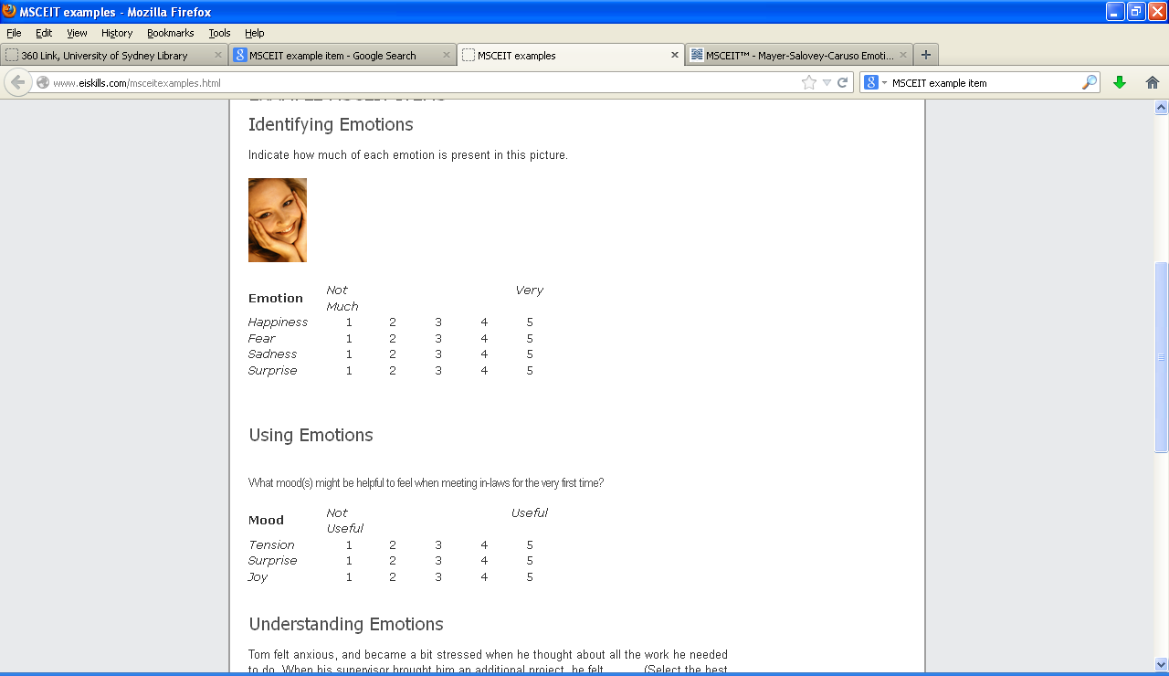


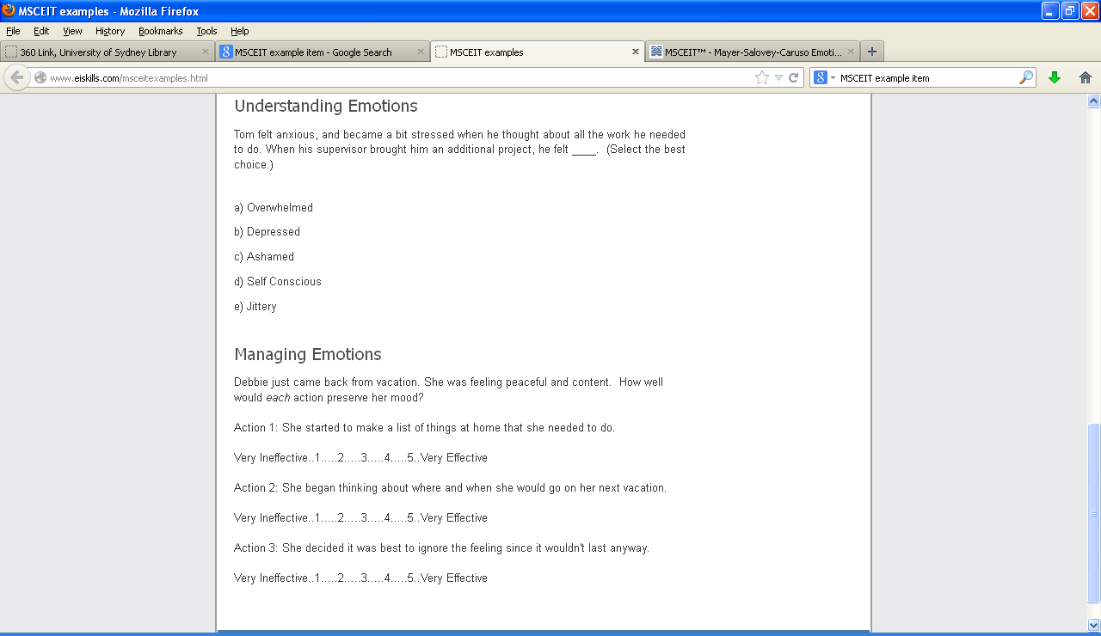


Narcissism Scale
Scale
1-100 slider: Strongly Agree to Strongly disagree

Grandiosity
Exploitativeness
4. I can usually talk my way out of anything.
10. I can make anyone believe anything I want them to.
15. I find it easy to manipulate people.
23. I can read people like a book.
Self-Sacrificing Self-Enhancement
22. I feel important when others rely on me.
25. Sacrificing for others makes me the better person.
33. I like to have friends who rely on me because it makes me feel important.
39. I try to show what a good person I am through my sacrifices.
Grandiose Fantasy
26. I often fantasize about accomplishing things that are probably beyond my means.
31. I often fantasize about being rewarded for my efforts.
42. I often fantasize about performing heroic deeds.
45. I often fantasize about being recognized for my accomplishments.
Vulnerability
Contingent Self-Esteem
8. When people don’t notice me, I start to feel bad about myself.
30. It’s hard to feel good about myself unless I know other people admire me.
32. I am preoccupied with thoughts and concerns that most people are not interested in me.
36. It’s hard for me to feel good about myself unless I know other people like me.
Hiding the Self
9. I often hide my needs for fear that others will see me as needy and desperate.
28. It’s hard to show others the weaknesses I feel inside.
46. I can’t stand relying on other people because it makes me feel weak.
50. When others get a glimpse of my needs, I feel anxious and ashamed.
Devaluing
17. Sometimes I avoid people because I’m concerned that they’ll disappoint me.
21. When others don’t meet my expectations, I often feel ashamed about what I wanted.
27. Sometimes I avoid people because I’m afraid they won’t do what I want them to do.
34. Sometimes I avoid people because I’m concerned they won’t acknowledge what I do for them.
Entitlement Rage
12. I get annoyed by people who are not interested in what I say or do.
18. I typically get very angry when I’m unable to get what I want from others.
37. It irritates me when people don’t notice how good a person I am.
38. I will never be satisfied until I get all that I deserve.

